# Process Engine Tool Stack

## Links

Activiti Workflow Engine  
<https://en.wikipedia.org/wiki/Activiti_(software)>

Spring application framework + IOC (inversion of control) container  
<https://en.wikipedia.org/wiki/Spring_Framework>

Hibernate OR (object-relational) mapping + persistence  
<https://en.wikipedia.org/wiki/Hibernate_(framework)>

LDAP distributed directory information   
<https://en.wikipedia.org/wiki/Lightweight_Directory_Access_Protocol>

Camel Enterprise Integration Patterns + routing  
<https://en.wikipedia.org/wiki/Apache_Camel>

ActiveMQ JMS message broker  
<https://en.wikipedia.org/wiki/Apache_ActiveMQ>

Scala full support for functional programming  
<https://en.wikipedia.org/wiki/Scala_(programming_language)>  
<https://en.wikipedia.org/wiki/Functional_programming>

Akka concurrent and distributed applications + (emphasizes) actor-based  
<https://en.wikipedia.org/wiki/Akka_(toolkit)>

Gradle build automation system + Groovy DSL (<-> Ant, Maven)  
<https://en.wikipedia.org/wiki/Gradle>

Center-piece of DevOps:  
<https://en.wikipedia.org/wiki/DevOps_toolchain>

Repository SVN + Artifactory  
<https://en.wikipedia.org/wiki/Binary_repository_manager>

## Activiti

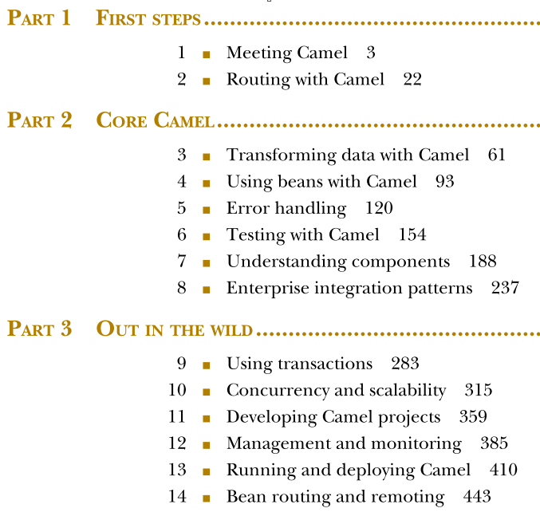

## Camel

